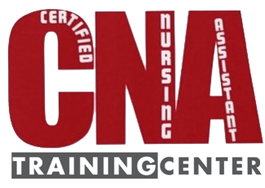 | 1341 Northcrest Drive  Crescent City, CA 95531  (707) 465-4186  M-F 11am-4pm  cnatrainingcenter@frontier.com  www.cnatrainingcenter.weebly.com

Applicant Information
Full Name: |  |  |  | Date:
 | Last | First | M.I.

Address:
 | Street Address | Apartment/Unit #

 | City | State | ZIP Code

Phone: |  | Email

Are you a citizen of the United States? | YES | NO | If no, are you authorized to work in the U.S.? | YES | NO

Are you at least 18 yrs of age or older? | YES | NO

Do you have a HS diploma or GED equivalency? | YES | NO

References
Please list three professional references.
Full Name: |  | Relationship:
Company: |  | Phone:
Address:

Disclaimer and Signature
I certify that my answers are true and complete to the best of my knowledge.
If this application leads to employment, I understand that false or misleading information in my application or interview may result in my release.
Signature: |  | Date:

